Autoencoder-Based Product Recommendation System for Influencers & Amazon Products

Input:

**Pool 1**: Features generates for candidate sponsored posts and the corresponding product, considered relevant to the current user (derived on the basis of collaborative filtering)

**Pool 2**: Available Amazon product features across across categories. Recommendations will be made across categories.

Clothing_Shoes_and_Jewelry

Books

Electronics

Sports_and_Outdoors

Grocery_and_Gourmet_Food

All_Beauty

Health_and_Personal_Care

Movies_and_TV

Automotive

CDs_and_Vinyl

Video_Games

Digital_Music

Candidate Post (Relevant to user)

user_id 14198415

user_name travisbarker

follower_count 8576230

category Musician

avg_likes_per_post(k) 401.6

ad_product_name music_show

ad_product_category Digital_Music

advertising_brand 5sos

predicted_likes(k) 377.1

engagement_change -0.061

recommendation_score 0.028184

product_info digital_music music_show 5sos

influencer_product_fit 0.274324

comprehensive_score 30.3

**Recommended products**

**Product 1 (Similarity = 0.5169)**

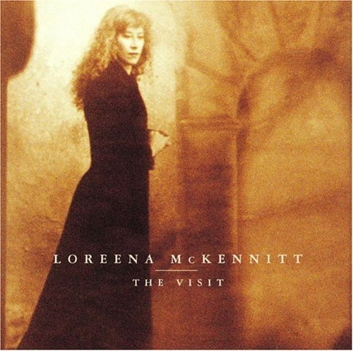

| main_category | Digital Music |
| --- | --- |
| title | The Visit by Mckennitt, Loreena [Music CD] |
| average_rating | 4.8 |
| rating_number | 205 |
| price | 9.9 |
| store | Format: Audio CD |
| details | {'Date First Available': 'November 19, 2014'} |
| parent_asin | B00PUUHE6S |

**Product 2 (Similarity = 0.5154)**

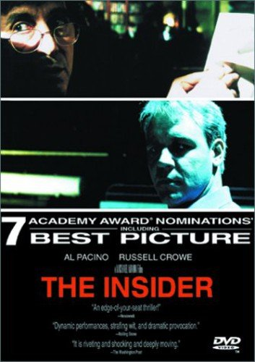

| main_category | Movies & TV |
| --- | --- |
| title | The Insider |
| average_rating | 4.6 |
| rating_number | 1600 |
| price | 7.89 |
| store | Russell Crowe (Actor), Al Pacino (Actor), Michael Mann (Director, Producer, Writer) & 0 more Rated: R Format: DVD |
| categories | ['Movies & TV', 'Genre for Featured Categories', 'Drama'] |
| details | {'Genre': 'Drama', 'Format': 'Multiple Formats, AC-3, Closed-captioned, Color, Dolby, NTSC, Widescreen', 'Contributor': 'Colm Feore, Gusmano Cesaretti, Al Pacino, Stephen Tobolowsky, Avi Kleinberger, Michael Mann, Marie Brenner, Kathleen M. Shea, Philip Baker Hall, Christopher Plummer, Russell Crowe, Bruce McGill, Eric Roth, Diane Venora, Debi Mazar, Gina Gershon, Michael Gambon, Lindsay Crouse, Pieter Jan BruggeColm Feore, Gusmano Cesaretti, Al Pacino, Stephen Tobolowsky, Avi Kleinberger, Michael Mann, Marie Brenner, Kathleen M. Shea, Philip Baker Hall, Christopher Plummer, Russell Crowe, Bruce McGill, Eric Roth, Diane Venora, Debi Mazar, Gina Gershon, Michael Gambon, Li… See more', 'Language': 'English (Dolby Digital 5.1), Unqualified', 'Runtime': '2 hours and 37 minutes', 'Aspect Ratio': '2.35:1', 'Is Discontinued By Manufacturer': 'No', 'MPAA rating': 'R (Restricted)', 'Product Dimensions': '0.6 x 5.4 x 7.5 inches; 2.4 Ounces', 'Item model number': 'WD01929800DVD', 'Director': 'Michael Mann', 'Media Format': 'Multiple Formats, AC-3, Closed-captioned, Color, Dolby, NTSC, Widescreen', 'Run time': '2 hours and 37 minutes', 'Release date': 'April 11, 2000', 'Actors': 'Russell Crowe, Al Pacino, Christopher Plummer, Diane Venora, Philip Baker Hall', 'Producers': 'Michael Mann, Avi Kleinberger, Gusmano Cesaretti, Kathleen M. Shea, Pieter Jan Brugge', 'Studio': 'TOUCHSTONE PICTURES', 'Writers': 'Michael Mann, Eric Roth, Marie Brenner', 'Country of Origin': 'USA', 'Number of discs': '1'} |

**Product 3 (Similarity = 0.5169)**

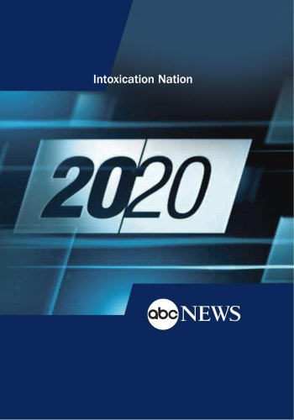

| main_category | Movies & TV |
| --- | --- |
| title | 20/20: Intoxication Nation: 9/21/12 |
| average_rating | 4.6 |
| rating_number | 13 |
| description | ['"20/20" reports on drinking in America today. Reports include: Actress Kristen Johnston: What is it about celebrity that seems to spawn alcoholism? In a revealing and often hilarious interview, former "3rd Rock from the Sun" star Kristen Johnston speaks candidly about the harrowing experiences of being a young actress whose insecurity and struggles with fame led to an addiction problem which nearly killed her. Kids These Days: Kids these days are devising more degenerate and dangerous ways to get wasted. As former teen alcoholic Koren Zailckas says, behavior that was once considered uncool - like drinking until you black out - is now being celebrated. Vodka now comes in kid-friendly flavors like bubble gum, cotton candy, marshmallow and peanut butter & jelly. Kids don\'t even need fake IDs anymore -- some online vendors will ship alcohol to anyone who places an order. Cuomo reports. DUI Wars: In their efforts to crack down on drunk driving, cops are doing much more than videotaping and random checkpoints; they are also conducting undercover stings in bars and dispensing summonses before drunks ever get in their vehicles. Drunk Walking Dangers: The girl who stumbled into the wrong house and got herself shot... The countless drunk pedestrians who get hit by cars. These stories are emblematic of a widely under-reported phenomenon, the dangers of drunken walking. . Hangover Helpers: As long as there have been people drinking too much, there have been people looking for a hangover cure, and others offering to sell them. The latest is the Las Vegas Hangover Bus, developed by a Nevada doctor, which makes house calls to hotels along the strip, infusing hungover partiers with intravenous fluids and nutrients. Airdate: 9/21/12'] |
| store | Format: DVD |
| categories | ['Movies & TV', 'ABC News'] |
| details | {'Aspect Ratio': '1.33:1', 'Product Dimensions': '7.5 x 5.5 x 0.5 inches; 3.2 Ounces', 'Item model number': 'B009SV4O2M', 'Media Format': 'NTSC', 'Run time': '33 minutes', 'Release date': 'October 19, 2012', 'Studio': 'ABC News', 'Number of discs': '1'} |

**Product 4 (Similarity = 0.5169)**

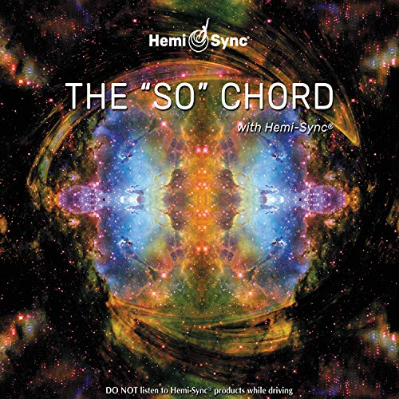

| main_category | Digital Music |
| --- | --- |
| title | The 'so' Chord |
| average_rating | 4.7 |
| rating_number | 9 |
| description | ['The SO Chord\xa0is one of many interpretations of the formative sound of Creation emerging from the Void. When combined with Hemi-Sync®, Barry Osers SO Chord provides an ideal sonic background to support experiential meditation. Any sound might appear as you listen to the powerful vibrational harmonics of\xa0The SO Chord\xa0(frequently one hears music that is not part of the recording). Restore balance and harmony to your mind-body with this extraordinary meditative tool. For optimum results, listen in one sessionpreferably in a darkened, meditative environment. Non-verbal.'] |
| price | 28.67 |
| store | Oser, Barry (Artist) Format: Audio CD |
| details | {'Is Discontinued By Manufacturer': 'No', 'Product Dimensions': '4.92 x 5.51 x 0.39 inches; 3.53 Ounces', 'Manufacturer': 'Hemi-Sync', 'Date First Available': 'November 16, 2010', 'Label': 'Hemi-Sync', 'Number of discs': '1'} |